A PROJECT REPORT
ON
MAC ADDRESS FINDER
A Dissertation submitted to JNTU Hyderabad in partial fulfillment of the academic requirements for the award of the degree
Bachelor of Technology
In
Computer Science and Engineering (Data Science)

Under the esteemed guidance of
Mr. Uday Kishore / Ms. Akanksha


COMPUTER SCIENCE AND ENGINEERING (DATA SCIENCE)

CMR COLLEGE OF ENGINEERING & TECHNOLOGY
(Autonomous)
(NAAC Accredited with ‘A⁺’ Grade & NBA Accredited)
(Approved by AICTE, Permanently Affiliated to JNTU Hyderabad)
KANDLAKOYA, MEDCHAL ROAD, HYDERABAD-501401
2026-2027

CMR COLLEGE OF ENGINEERING & TECHNOLOGY
(Autonomous)
(NAAC Accredited with ‘A⁺’ Grade & NBA Accredited)
(Approved by AICTE, Permanently Affiliated to JNTU Hyderabad)
KANDLAKOYA, MEDCHAL ROAD, HYDERABAD-501401

DEPARTMENT OF COMPUTER SCIENCE AND ENGINEERING
(DATA SCIENCE)

CERTIFICATE
This is to certify that the Computer Networks Laboratory Project report entitled “MAC ADDRESS FINDER” being submitted by Arna Malwatkar (24H51A6767), Banala Jashwanth (24H51A6770), and Banala Sushanth (24H51A6771) of Bachelor of Technology in Computer Science and Engineering (Data Science) is a record of Bonafide work carried out his/her under the guidance and supervision.
The results embody in this project report have not been submitted to any other University or Institute for the award of any Degree.

Mr. Uday Kishore / Ms. Akanksha Dr. R. Venkateswara Reddy
Assistant Professors Associate Professor and HOD
Dept. of CSE(DS) Dept. of CSE(DS)

ACKNOWLEDGEMENT
With great pleasure we want to take this opportunity to express our heartfelt gratitude to all the people who helped in making this project work a grand success.
We are grateful to Mr. Uday Kishore / Ms. Akanksha, Assistant Professors, Department of Computer Science and Engineering (Data Science) for their valuable technical suggestions and guidance during the execution of this project work.
We would like to thank Dr. R. Venkateswara Reddy, Head of the Department of Computer Science and Engineering (Data Science), CMR College of Engineering and Technology, who is the major driving forces to complete my project work successfully.
We are highly indebted to Dr. K. Srinivasa Rao, Principal, CMR College of Engineering and Technology, for giving permission to carry out this project in a successful and fruitful way.
We would like to thank the Teaching & Non-teaching staff of Department of Computer Science and Engineering (Data Science) for their co-operation.
We express our sincere thanks to Shri. Ch. Gopal Reddy, Secretary, CMR Group of Institutions, for his continuous care.
Finally, we extend thanks to our parents who stood behind us at different stages of this Project. We sincerely acknowledge and thank all those who gave support directly and indirectly in completion of this project work.

TABLE OF CONTENTS
CHAPTER NO. | TITLE | PAGE NO.
 | Abstract | 1
1 | INTRODUCTION
 | 1.1 Problem Statement | 2
 | 1.2 Objective | 2
 | 1.3 Scope | 2
 | 1.4 Limitations | 3
2 | PROPOSED SYSTEM
 | 2.1 Advantages | 4 - 5
 | 2.2 Design | 5
 | 2.3 Implementation | 5 - 7
3 | RESULTS AND DISCUSSION | 8 - 9
4 | FUTURE SCOPE | 10
5 | CONCLUSION | 11

ABSTRACT
The MAC Address Finder is a C-based Computer Networks project developed to identify and display the MAC addresses of network adapters available on a local computer. A MAC (Media Access Control) address is a unique hardware address associated with a network interface and is mainly used for communication at the Data Link Layer. The system uses the Windows IP Helper API to obtain information about the network adapters installed on the computer. The program detects the available network adapters, retrieves their MAC addresses, and displays the information in a simple command-line interface. The project provides a practical demonstration of network interface identification and MAC addressing concepts using the C programming language.
A computer can have multiple network interfaces such as Wi-Fi, Ethernet, or Bluetooth. Each network interface generally has a MAC address that identifies it at the Data Link Layer of a network.
Finding the MAC address manually may require checking different operating system settings or commands. The MAC Address Finder provides a simple C-based solution that automatically detects the network adapters available on the computer and displays their MAC addresses.
The project uses the Windows IP Helper API to communicate with the operating system and obtain network adapter information.

CHAPTER 1
INTRODUCTION
  - Problem Statement
Identifying the MAC address of a computer's network interfaces manually can be inconvenient, especially when multiple network adapters are present.
The proposed system solves this problem by automatically detecting the network adapters and displaying their corresponding MAC addresses through a simple C program.

  - Objective
The main objective of the project is:
- To detect the network adapters available on a local computer.
- To retrieve the MAC address of each detected adapter.
- To display the MAC addresses in a clear and readable format.
- To demonstrate the practical concept of MAC addressing using C.
- To understand how a program can obtain network interface information from the operating system.

1.3 Scope:
The scope of this project is limited to finding MAC addresses of network adapters on the local computer.
The system:
- Detects available network adapters.
- Retrieves their MAC addresses.
- Displays the adapter name and corresponding MAC address.
- Works as a command-line C application on Windows.

The project does not attempt to scan or identify devices connected to the entire local network.

1.4 Limitations:
- The program is designed for Windows systems using the Windows IP Helper API.
- It finds MAC addresses of adapters on the local computer only.
- It does not find the MAC addresses of other devices on the network.
- It does not perform packet capture or network traffic monitoring.
- It uses a command-line interface rather than a graphical interface.
- The information displayed depends on the network adapters detected by the operating system.

CHAPTER 2
PROPOSED SYSTEM
The proposed system is a C-based MAC Address Finder that automatically retrieves the MAC addresses of network adapters available on the local computer.
The program uses the Windows IP Helper API, particularly the GetAdaptersInfo() function, to obtain network adapter information.
The basic working process is:
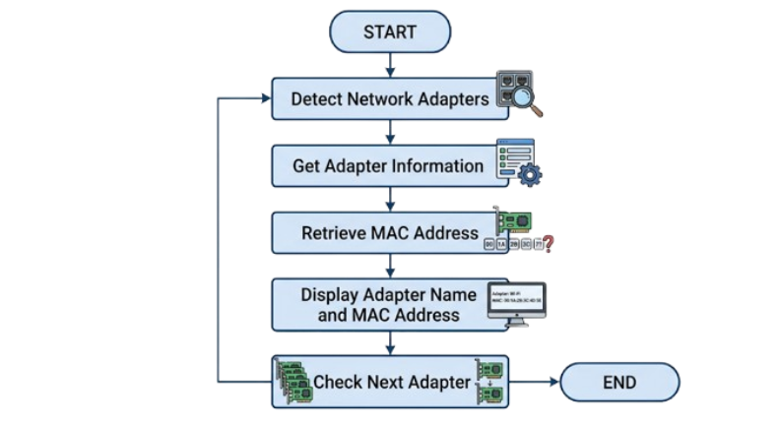
2.1 Advantages
The proposed system provides the following advantages:
- Simple: The program has a straightforward command-line interface.
- Automatic: Network adapters are detected automatically.
- Accurate: MAC addresses are obtained directly from the operating system.
- Fast: The program retrieves adapter information quickly.
- No manual entry: The user does not need to enter a MAC address.
- Multiple adapters: The program can display MAC addresses for multiple network adapters.
- Educational: It demonstrates practical concepts related to network interfaces and MAC addressing.

- Lightweight: The program does not require a database or a separate application server.
2.2 Design
The project follows a simple design in which the C program interacts with the Windows networking system.
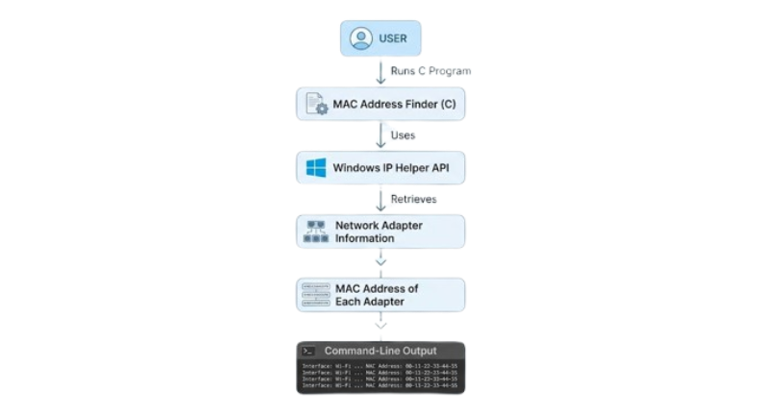
Main Components:
1. C Program: The main C program controls the complete execution of the application. It requests network adapter information and displays the results.
2. Windows IP Helper API: The Windows IP Helper API provides functions for accessing network configuration and adapter information. The project uses GetAdaptersInfo() to retrieve adapter details.
3. Network Adapter Information: The operating system provides information about the network adapters installed on the computer. The program processes this information to obtain the MAC address.
4. Command-Line Interface: The retrieved information is displayed to the user through the command prompt.
2.3 Implementation
The project is implemented using the C programming language on a Windows system.

The main steps involved in implementation are:

Step 1: Include Required Libraries: The program includes libraries required for standard input/output, Windows functionality, memory allocation, and IP Helper API functions.
#include <stdio.h>
#include <stdlib.h>
#include <windows.h>
#include <iphlpapi.h>
Step 2: Link the IP Helper Library: The following statement links the required Windows networking library:
#pragma comment(lib, "iphlpapi.lib")
Step 3: Obtain Adapter Information: The GetAdaptersInfo() function is used to retrieve information about the network adapters available on the computer.
Step 4: Process Each Adapter: The program uses the adapter information returned by Windows and processes each adapter one by one.
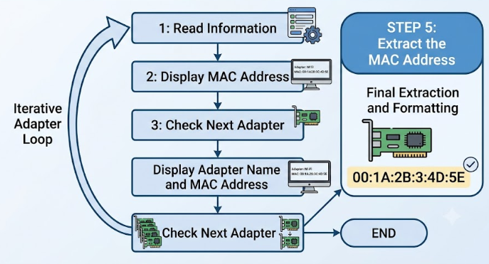
Step 5: Extract the MAC Address: The MAC address is stored as a sequence of bytes. The program uses a loop to read each byte and prints it in hexadecimal format.
For example:
40 8C F0 A1 B2 C3 is displayed as: 40-8C-F0-A1-B2-C3

Step 6: Display the Result: The program displays the network adapter name and its corresponding MAC address in the command prompt.

Overall Algorithm:
START
1. Initialize the program.
2. Determine the required memory size for storing adapter information.
3. Allocate memory.
4. Call GetAdaptersInfo() to retrieve network adapter information.
5. Select the first network adapter.
6. Display the adapter name.
7. Read the MAC address bytes.
8. Convert the MAC address bytes into hexadecimal format and display them.
9. Move to the next adapter.
10. Repeat Steps 6–9 until all adapters have been processed.
11. Release allocated memory.
12. END

CHAPTER 3
RESULTS AND DISCUSSION
Results:
The developed MAC Address Finder successfully detects the network adapters available on the local Windows computer and displays their MAC addresses.
A typical output of the program is:
========================================
MAC ADDRESS FINDER
========================================
Interface : Wi-Fi
MAC Address: XX-XX-XX-XX-XX-XX
----------------------------------------
Interface : Ethernet
MAC Address: XX-XX-XX-XX-XX-XX
----------------------------------------
Interface : Bluetooth
MAC Address: XX-XX-XX-XX-XX-XX
----------------------------------------
========================================

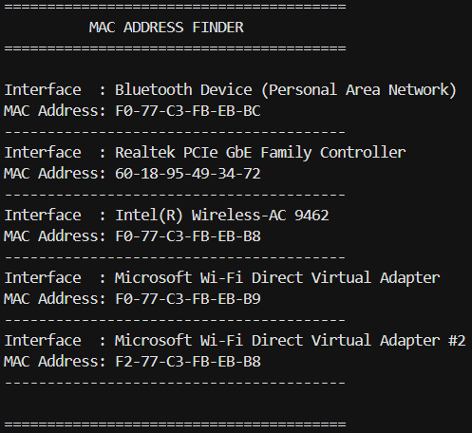
Discussion:
The exact number and names of the adapters depend on the computer on which the program is executed.
The result demonstrates that the program can successfully communicate with the Windows networking system, identify available network adapters, retrieve their MAC addresses, and display them to the user.

CHAPTER 4
FUTURE SCOPE
The current project is focused only on finding MAC addresses. In the future, the system can be extended with additional networking features such as:
- Detecting devices connected to the local network.
- Displaying additional network adapter information.
- Providing MAC address vendor information.
- Adding a graphical user interface.
- Providing options to save the retrieved information to a file.
- Supporting additional operating systems.
These features are outside the scope of the current implementation.

CHAPTER 5
CONCLUSION
The MAC Address Finder successfully provides a simple C-based method for identifying the MAC addresses of network adapters available on a Windows computer. The project uses the Windows IP Helper API to retrieve adapter information and processes the MAC address bytes before displaying them in a readable format.
The project provides practical understanding of MAC addressing, network adapters, the Data Link Layer, operating-system networking information, and C programming for network-related applications. It also demonstrates how networking concepts studied in Computer Networks can be implemented in a practical program.

